**Red Black Tree**

Red - Black Tree is another variant of Binary Search Tree in which every node is coloured either RED or BLACK. We can define a Red Black Tree as follows...

**Red Black Tree is a Binary Search Tree in which every node is coloured either RED or BLACK.**

In a Red Black Tree, the colour of a node is decided based on the Red Black Tree properties. Every Red Black Tree has the following properties.

**Properties of Red Black Tree**

* **Property #1:** Red - Black Tree must be a Binary Search Tree.
* **Property #2:** The ROOT node must have coloured BLACK.
* **Property #3:** The children of Red coloured node must have coloured BLACK. (There should not be two consecutive RED nodes).
* **Property #4:** In all the paths of the tree there must be same number of BLACK coloured nodes.
* **Property #5:** Every new node must have inserted with RED colour.
* **Property #6:** Every leaf (i.e. NULL node) must coloured BLACK.

**Example**

The following is a Red Black Tree which created by inserting numbers from 1 to 9.

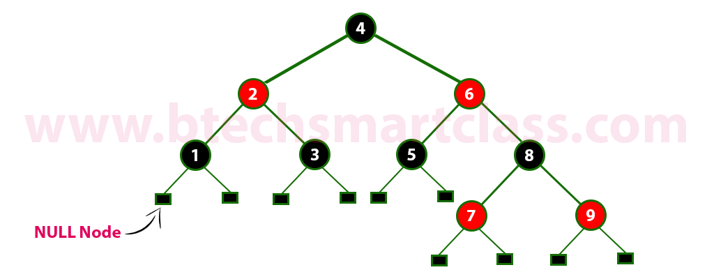

The above tree is a Red Black tree and every node is satisfying all the properties of Red Black Tree Every Red Black Tree is a binary search tree but all the Binary Search Trees need not to be Red Black trees.